Result

Datasets: | Vocabulary Size | Max-doc-length | Num_class | Train/Dev split | Train-Accuracy | Test-accuracy | Model_config：  filter_sizes：3,4,5 |  |  | Model_save
 |  |  |  |  |  |  | Embedding_
 |  |  |  |  |  |  | dim | init | static
bluescan | 1614 | 267 | 39 | 498/46
bluescan | 1613 |  | 14 | 497/46
bluescan –NoOther | 1436 | 232 | 12(pricing只出现一次，去掉了) | 255/86 |  | 0.709302 | 128 | rand | nonstatic | runs_bluescan/1496221930
 |  |  |  |  |  |  | 100 | glove | nonstatic
 |  |  |  |  |  | 0.825581
sentiment | 18758 | 56 | 2（5331+5331） | 9596/1066 |  | 0.71576  0.752345 | 128 | rand | nonstatic
SST
20-news-group | 131739 | 21273（长文本） |  | 10183/1131

Experiment

39个类别
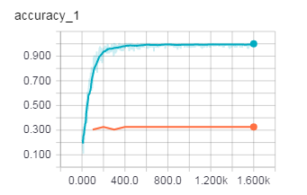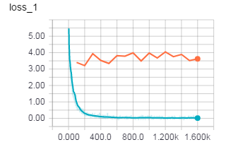
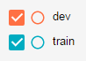

类别merge后 14个类别

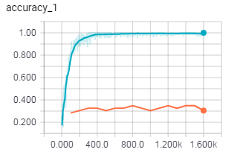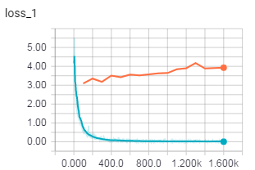

/data/xs/tensorflow/othermodels/cnn-text-classification-tf/runs/1493970224/prediction.csv
Accuracy: 0.304348

- 大多数都预测为other terms,
- 训练集 测试集分配不均，需要重新分配

